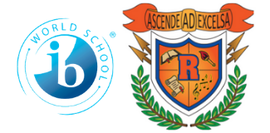

Ridgeway International Baccalaureate

Middle World Optional School

2023-2024

7th Grade School Supply List

2 Rolls Paper Towels

**TI 30 XS- Calculator**

**For All Classes:**

3 Ring Binder with 5 Dividers

4- Spiral Notebooks

-Notebook Paper- Wide Rule

-Highlighters

-Earbuds/Headphones

-Pens: 1 Pack of 4 assorted colors

-Pencils

-Colored Pencils

-Glue Sticks

Expo Markers (Dry Erase Markers)

-Scissors

-Pencil Sharpener

-Ruler

- Locker Rental Fee: $5 (Mandatory for ALL students – pay to Homeroom teacher)